1. Text

   Description automatically generated
2. 
   1. 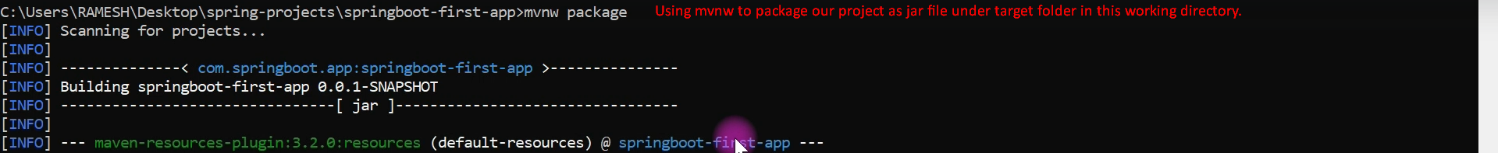
   2. Text

      Description automatically generated
   3. A picture containing graphical user interface

      Description automatically generated
3. 
   1. A screenshot of a computer

      Description automatically generated with medium confidence
   2. Text

      Description automatically generated